Data Science II

R School Enrollment Project
Part 3 - Final Results and Written Report

Aiden Rader
4/23/2026

Purpose / Data Introduction
In this project, I analyze how demographic, economic, and crime-related factors influence county-level school enrollment and migration patterns in the United States from 1990 to 2001. The primary outcome variable is annual school enrollment. To explain enrollment trends, I include economic variables such as per capita income and employment, as well as demographic variables like age and race composition. Crime data are also included to account for the impact of local safety conditions.

Variables / Hypothesis
The independent variables represent factors that may influence enrollment patterns. The proportion of individuals aged 15-24 captures youth population dynamics, while the proportion of nonwhite population reflects demographic composition. The proportion of males captures gender distribution effects. Economic variables such as per capita income and employment rate represent local economic conditions, while total crime rate captures safety-related influences. The variable year accounts for overall time trends. It is expected that stronger economic conditions increase enrollment, while higher crime rates and certain demographic shifts may lead to declines due to migration patterns.

Results
The final regression model (Model 2, see Figure 1) indicates that all included variables are statistically significant predictors of county-level school enrollment (p < 0.01 as seen in Figure 1). The proportion of nonwhite population shows a strong positive relationship with enrollment, while the proportion of individuals aged 15-24 and the proportion of males are negatively associated with enrollment. Total crime rate also has a negative relationship, suggesting that higher crime is linked to declining enrollment. Per capita income is positively related to enrollment, while employment rate shows a negative relationship. The time variable (year) is negative and significant, indicating an overall decline in enrollment over the study period. These results are consistent across both the full model and the refined model. Additionally, per capita income shows a strong upward trend over time (see Appendix Figure A1). One interesting takeaway is that demographic variables appear to have a stronger impact than economic variables in our final model.

Interpretation / $R^{2}$
The final model (Figure 1) has an adjusted $R^{2}$ of approximately 0.127, indicating modest explanatory power. This suggests that while the included variables significantly explain variation in enrollment, a large portion is still influenced by other unobserved factors. Among the predictors, the strongest effects are observed for demographic variables, particularly the proportion of nonwhite population and the proportion of individuals aged 15-24, which have large coefficient magnitudes and high statistical significance. The negative coefficient on total crime rate supports the hypothesis that higher crime is associated with declining enrollment, while the positive coefficient on per capita income suggests that stronger economic conditions contribute to increased enrollment. Overall, the results largely confirm the initial hypotheses and highlight the importance of demographic composition and local conditions in shaping school enrollment trends over time.

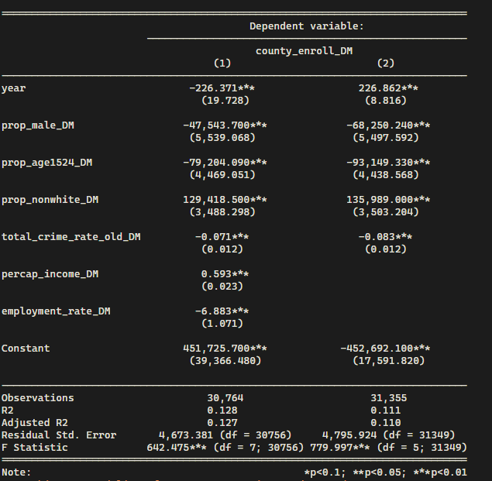
Summary Statistics
Figure 2: Comparison of Model 2 and Model 3
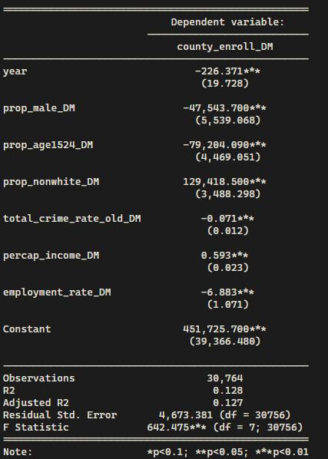
Figure 1: Final Regression Model Results

Appendices

Appendix A: Average Demeaned Per Capita Income Over Time
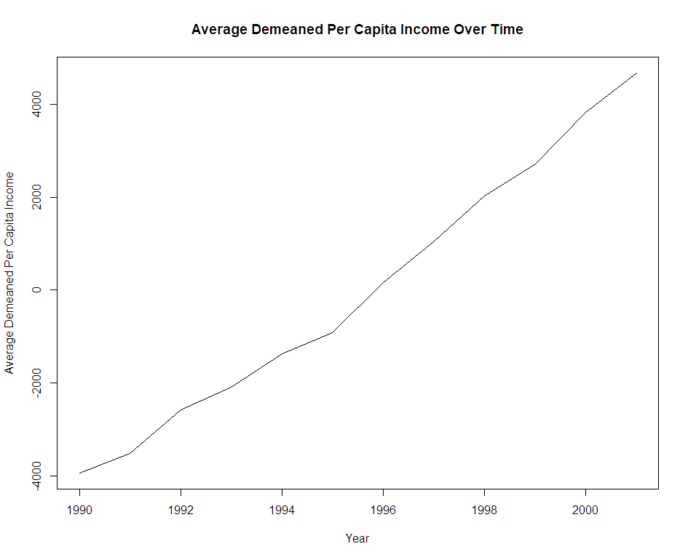
Figure A1: Average demeaned per capita income increased steadily from 1990 to 2001, indicating consistent economic growth over the study period.

